Advanced Matplotlib (Subplots & Styling)

Reminder
- Yesterday we drew basic plots (line, bar, histogram).
- Today → we learn how to make plots look professional using subplots & styling.

Subplots & Styling
- Subplots = multiple charts in one figure (compare side by side).
- Styling = customizing fonts, colors, grids, backgrounds, legends.
- Why important in data science?
👉 Clean, attractive visuals = easier insights & better storytelling.

Practical 1: Subplots
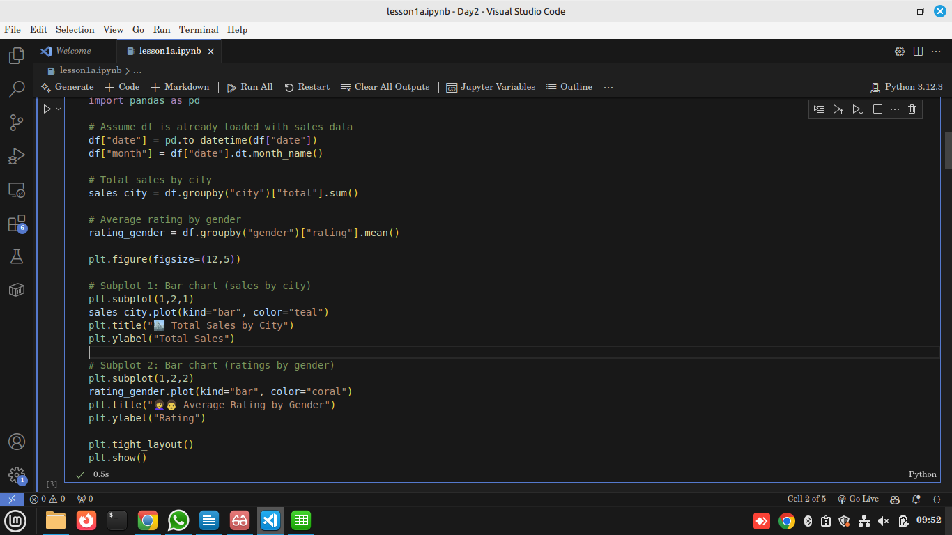
Output
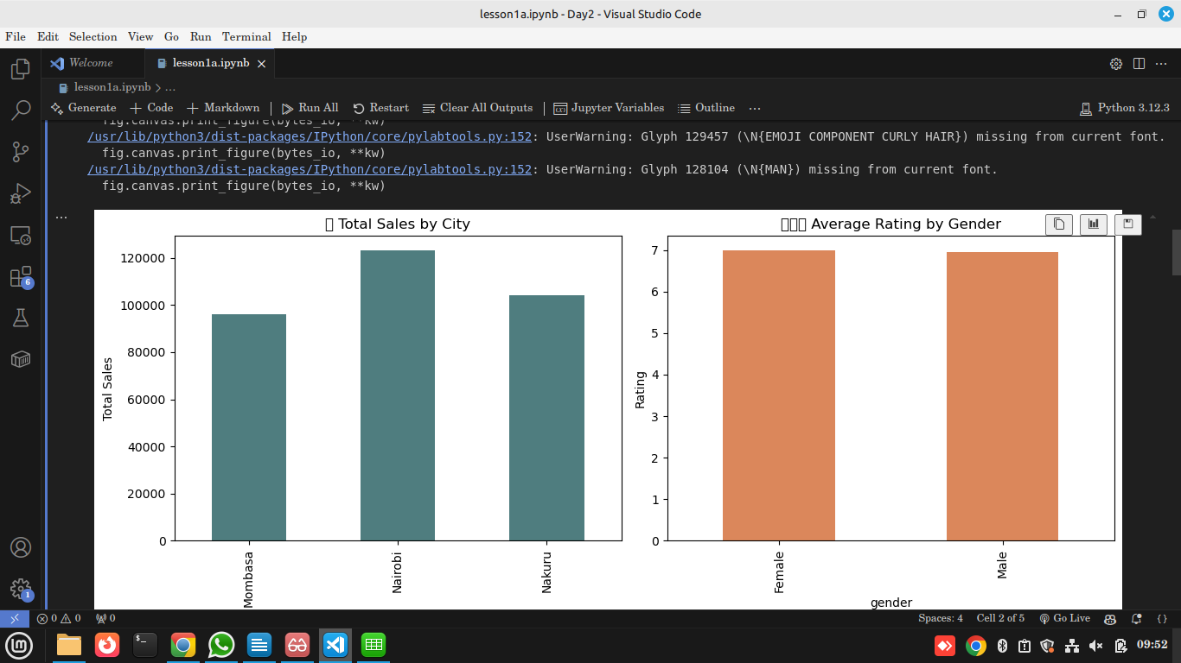
Explanation
- plt.subplot(1,2,1) → 1 row, 2 columns, 1st chart.
- plt.subplot(1,2,2) → 2nd chart.
- tight_layout() avoids overlap.
Use in Data Science
Subplots allow comparing two metrics in one glance (sales vs customer satisfaction).

Practical 2: Styling (Fonts, Colors, Grids, Legends)
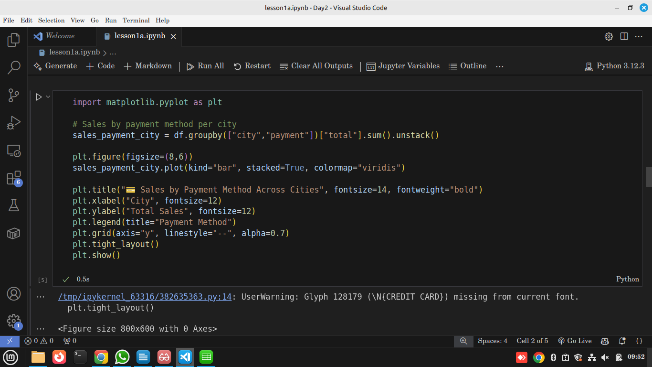
Output
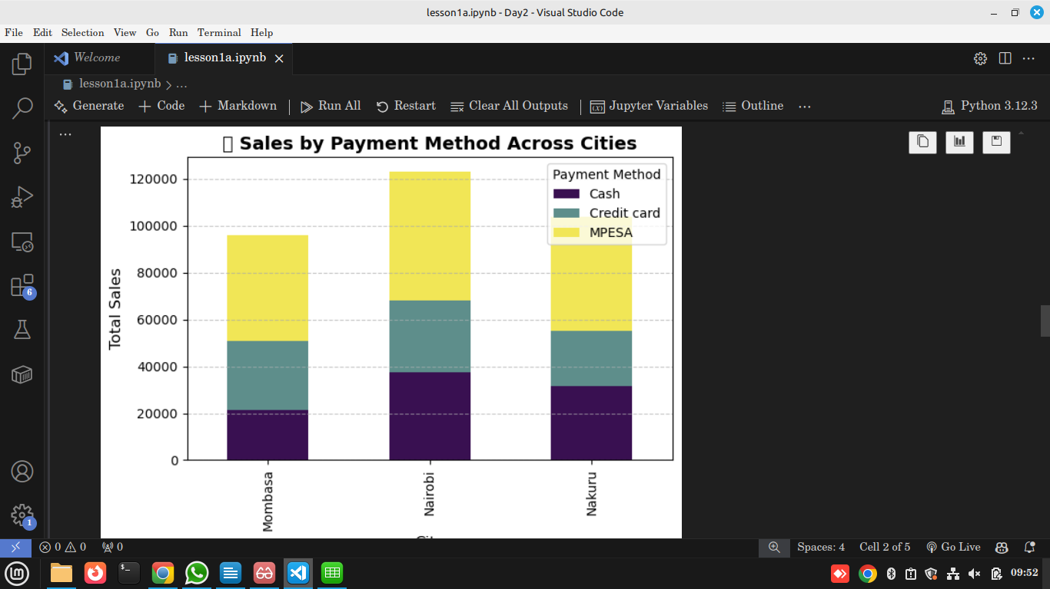

Explanation
- stacked=True → payments stacked inside each city bar.
- colormap="viridis" → modern gradient palette.
- grid(alpha=0.7) → improves readability.
Use in Data Science
Styling makes charts clearer for presentations/reports.

Assignment
(see assignment)

Reflection
- Why are subplots useful when comparing metrics?
- How does styling improve storytelling with data?

